10. File Handling

Table of Contents

|  |  |  |
| --- | --- | --- |
| Sl. No | Topics | Page No |
| 10.1 | **Understand File Operations** | **2** |

## 10.1 Understand File Operations

**What are the operations of a File?**

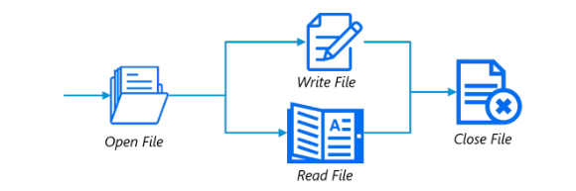

**How will you reading keyboard input?**

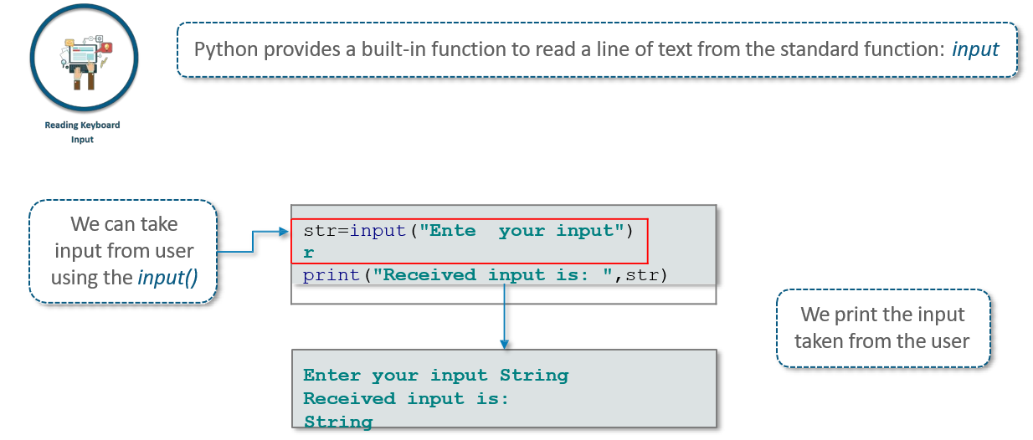

**File Manipulation**

**Python Files Input/output**

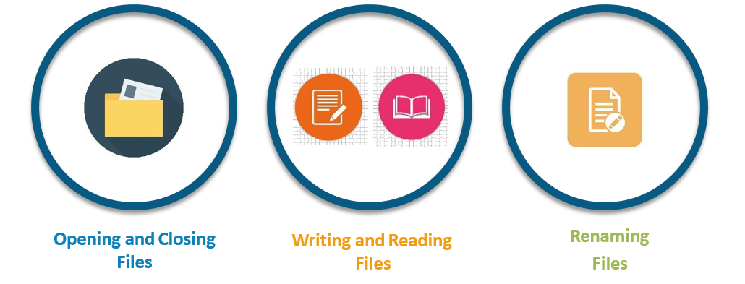

**Opening and Closing Files**

Before reading and writing any data into a file, it is important to learn how to open and close a file.

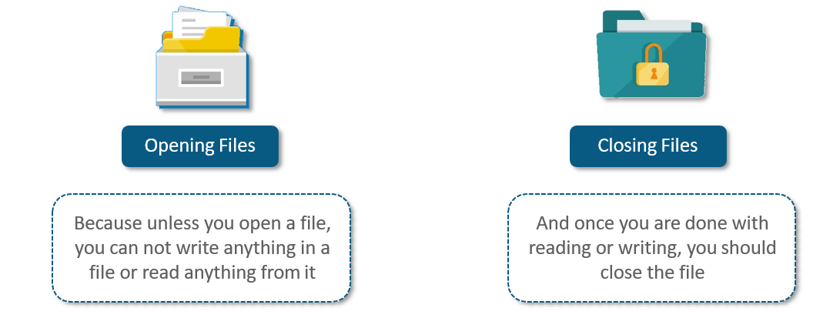

**Open Function**

You can open Files using Python's built-in *open()* function

file_Object=open(file_name,[access_mode])

Here are parameter details:

**file_name:** The file_name argument is a string value that contains the name of the file that you want to access

**access_mode:** The access_mode determines the mode in which the file has to be opened, i.e., read, write, and append

**Open Function – Access Modes**

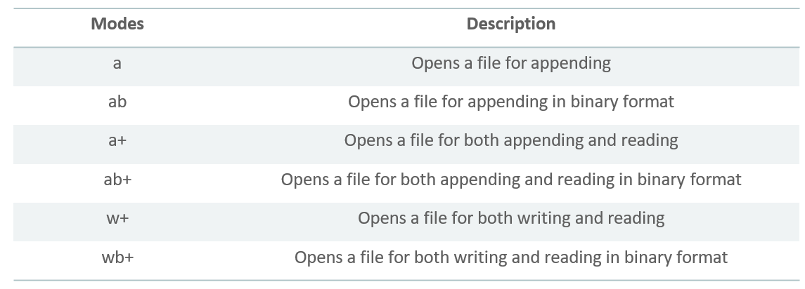

**Writing Files**

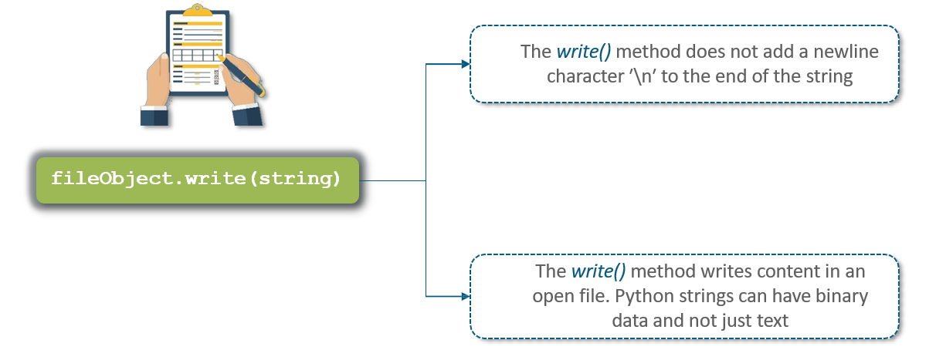

**Reading Files**

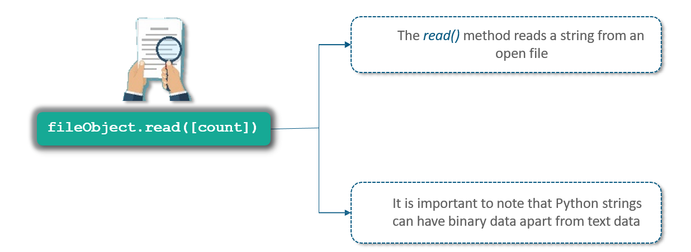

**Renaming Files**

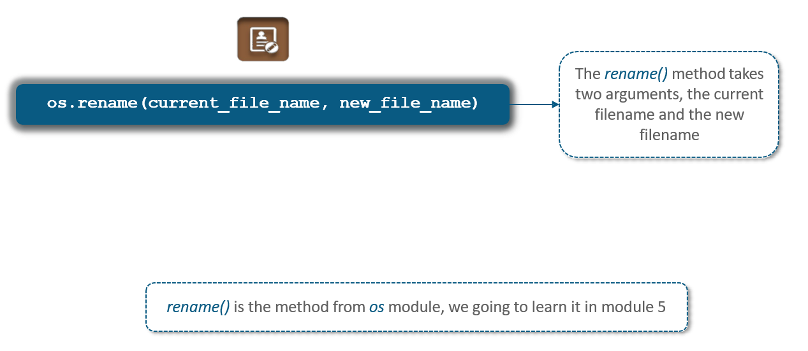

**Deleting Files**

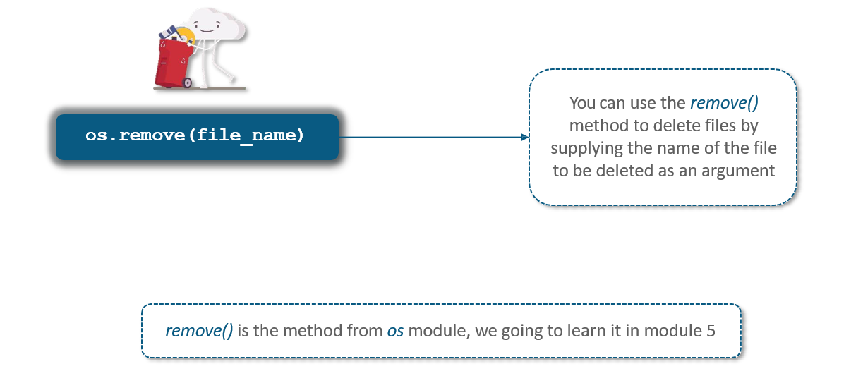

**Close Method**

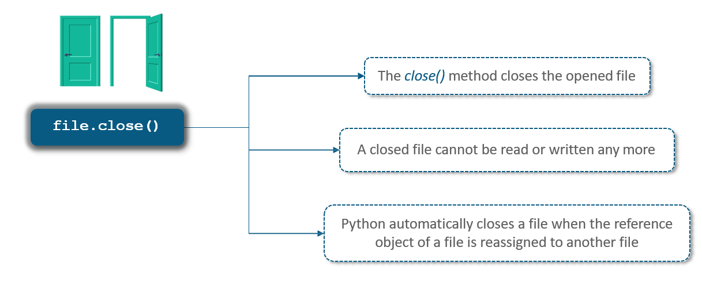

**File Object Attributes**

* Once a file is opened and you have one file object, various information related to that file can be obtained
* Here is a list of all attributes related to file object:-

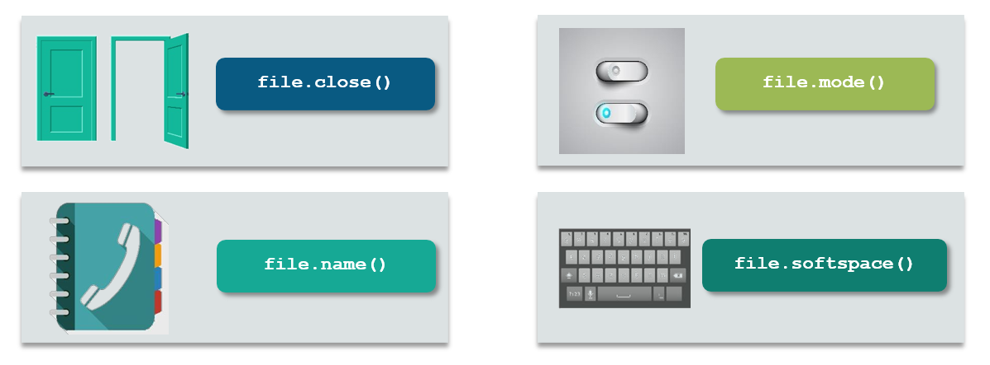

**File.name() and File.mode()**

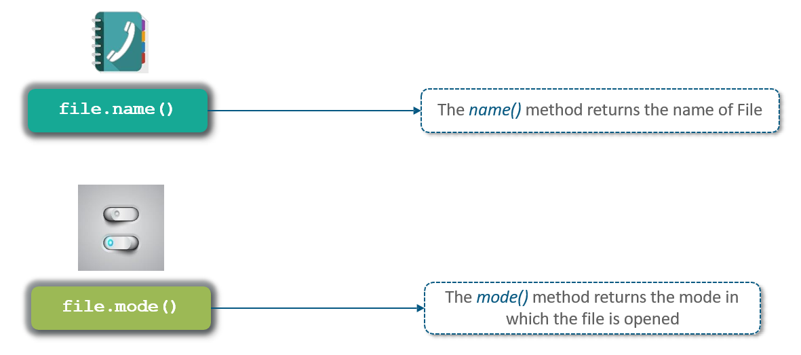

**File.softspace()**

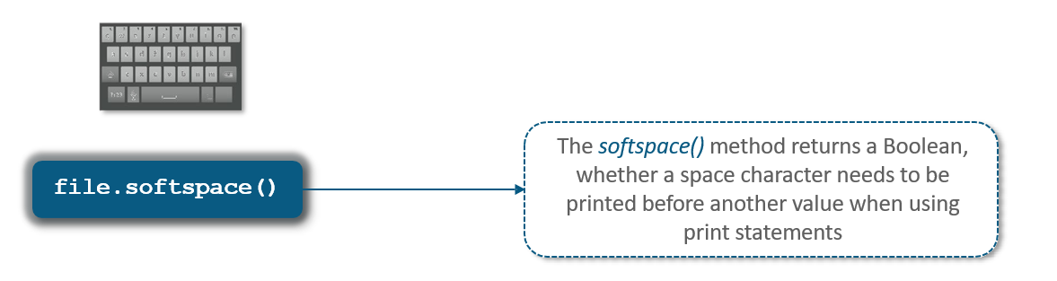

**File.seek() and File.tell()**

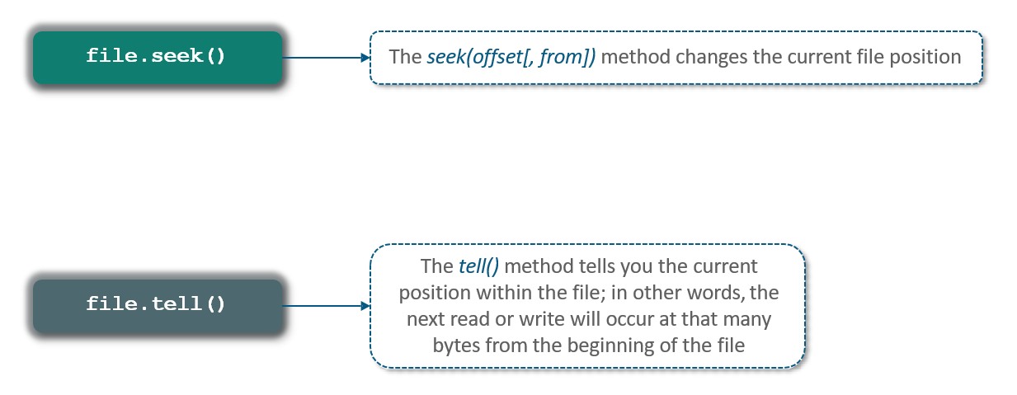

**What are the different Operations can be performed on a File?**

